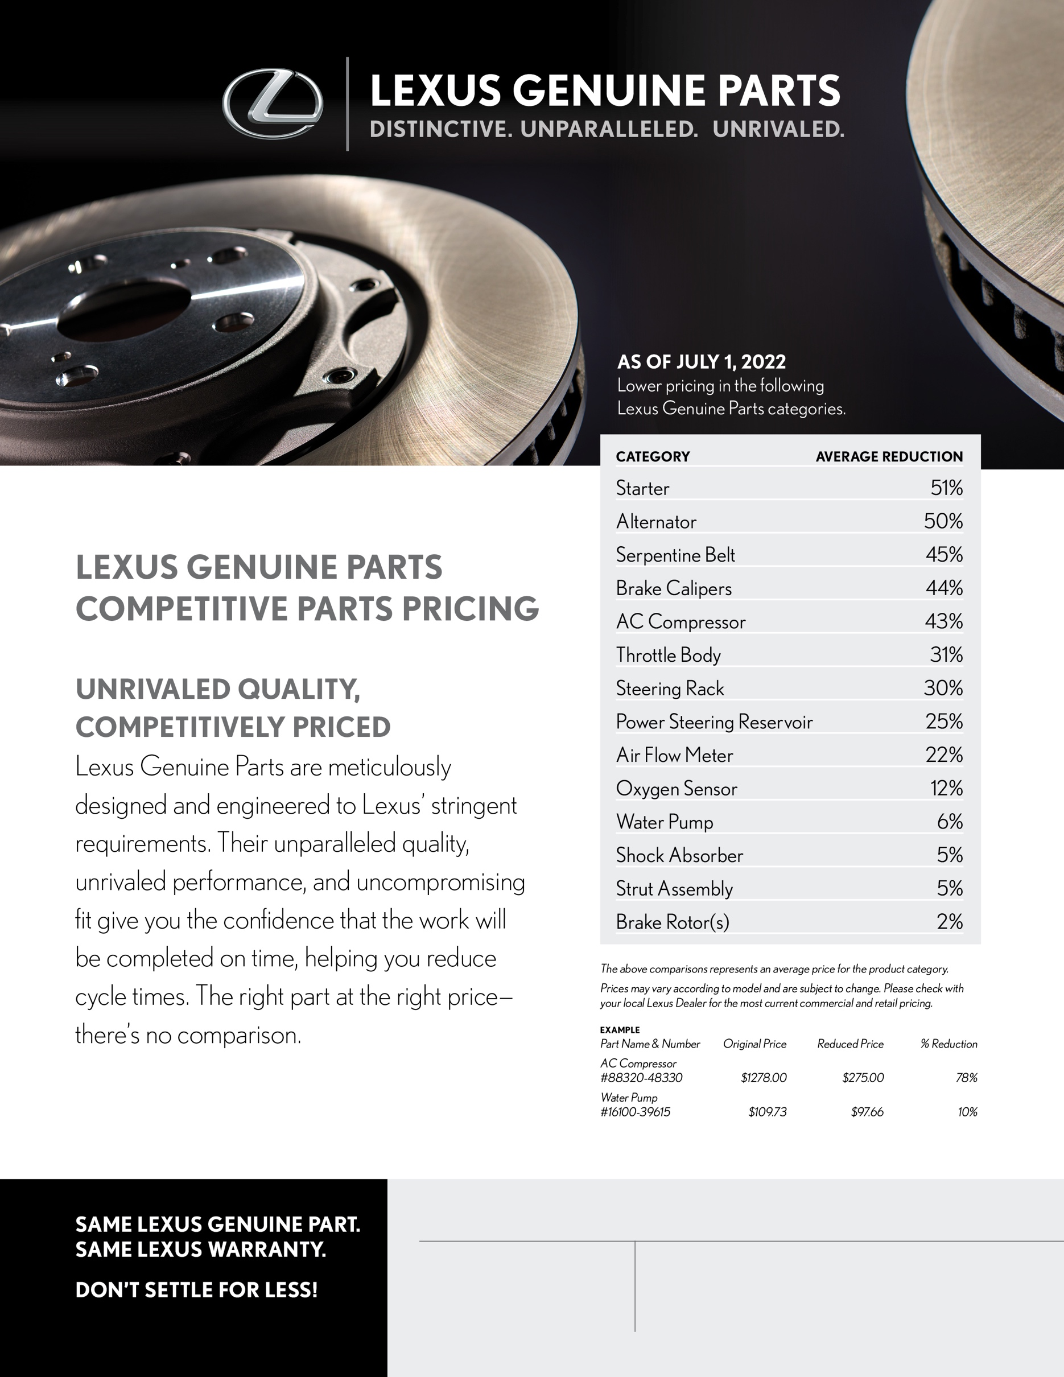
Dealership Name
Contact Name
Phone

Title
URL
Email

